Everything You Need to Know About BRICS Currency

**Introduction**  
 Amidst the ever-shifting waves of global business, there emerges a constellation of governments that grabs interest like few others — BRICS. Brazil, Russia, India, China, and South Africa, each a great superpower in its own right, come together under this banner with a similar purpose of economic collaboration and empowerment. Since its formation in 2009, BRICS has grown into more than just an abbreviation; it's a testament to the collective desire of developing powers keen to make their position on the world stage.

Even as the world is abuzz with discussion about the economy, there is one idea in BRICS that has piqued the interest of almost everyone. Imagine a world in which any of these differing economies are bound not only by similar principles but also by the same monetary policy. It is a concept that is intriguing enough to contemplate, propose, and create changes to the existing system that is based on the dollar. In this essay, we will begin an imaginary expedition through the BRICS currency, beginning with its concept, moving on to the possible problems with its development, and finally concluding its potential for the global economy.

**What is BRICS and BRICS Currency?**  
  
 Imagine competing on par with the world’s five economic behemoths in what can only be described as a different game. The League of BRICS, which was formed in 2009, is more than a convenient acronym. It is a metaphor for our mutual determination. There are a plethora of concepts currently fermenting in BRICS’ money bin, but if I had to select one that had far surpassed the controversial category, it would be the idea of a worldwide currency. It’s a type of financial level playing field that allows member states to trade and collaborate openly, thus boldly challenging the long-in-dominance beast.

**Limitations of Establishing a BRICS Currency**  
  
 Nevertheless, to state that creating one currency for the BRICS nations would not pose any difficulties is misleading. Picture several various economies with multiple local laws, customs, and local shaping factors. Now think of integrating all those systems into one monetary structure. Is it straightforward? Hardly. From structuring the currency rates into the possible approaches to lead the economies to minor harm, there are several disturbing questions to pose. Moreover, this task is complicated by global economy restraining measures, units disagreeing on trade policies, as well as constant reliance on geopolitics issues. A proper analogy would be leading on the economic swamps: you always need to speculate.  
  
**How Will the Formation of BRICS Currency Affect the US Dollar?**  
  
 Ah, but what regarding the huge show taking place in the worldwide phase? Envision, as you will, the ripple impact of BRICS Currency on the US dollar. As these growing titans lock arms behind a consistent monetary plan, the equilibrium of power worldwide of money begins to slide. Not caught in thrall to the dollar, BRICS nations are finally ready to go off and blaze a trail independently, enhancing gets and exhibiting savage brand-new financial power. Could this be the beginning of a gigantic shift, a tectonic mishap in the international round of financial administration? Only time will tell.

**Conclusion**  
  
 The world of global economics is a vast spectacle, and there are few other tales as exciting as BRICS and their ambition for a unified currency. The journey remains very rocky, but the possible outcome would be nothing short of earth-shattering. If the BRICS continue to secure positions and soak influence all over the world, a unified currency would lead to an entirely new age of international financial cooperation. Thus, dear comrade, get ready as the world of banking is only about to flip.

In the unfolding of the BRICS journey, there is a calendar opportunity to reflect on the complexity of global banking, the power transactions in play, and the potential for creativity and collaboration on a scale never contemplated. With each step taken, a Unified BRICS Currency, as with all situations full of potential, it’s the what-if that turns conventional wisdom on its head.

**Plagiarism Report**

Duplichecker:

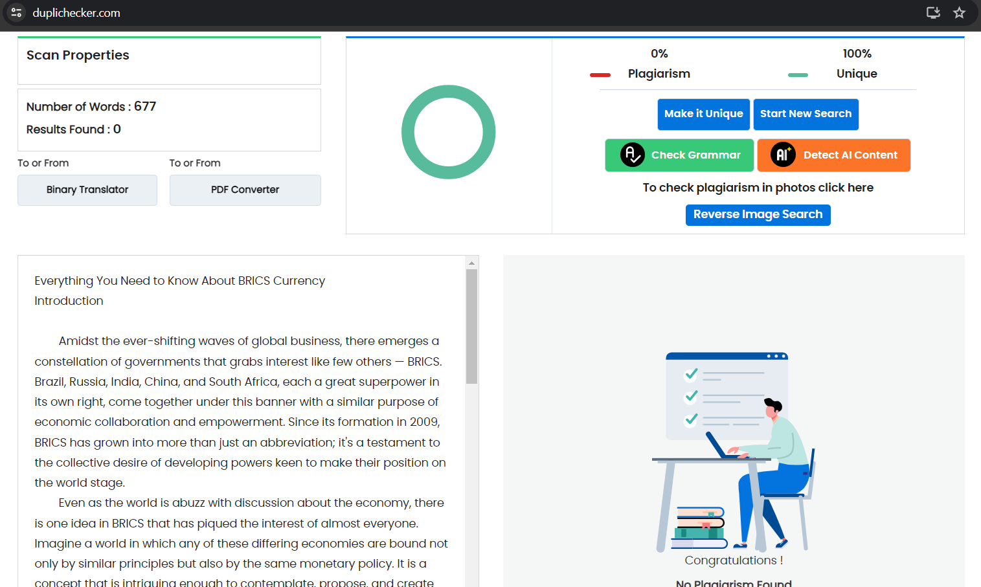

**AI Detection Report**

ZeroGPT:

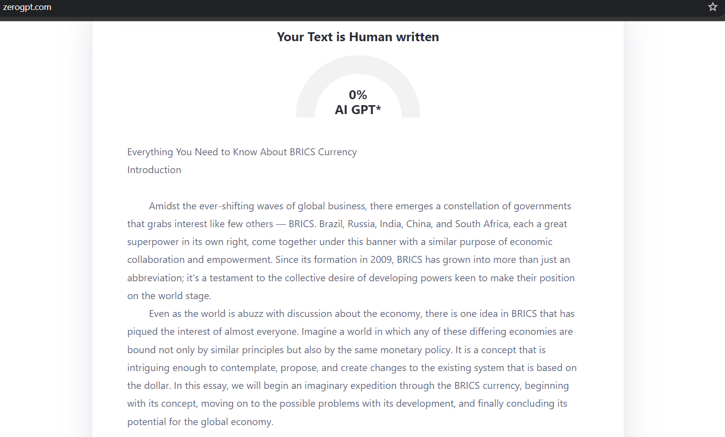

Copyleaks:

